The Impact of Data Quality on Machine Learning Model Performance

Medvedev Ivan
State Budgetary Educational Institution of the City of Moscow
“School No. 626 named after N.I. Sats”
Grade 11
Scientific Research project
2026

Abstract

This research examines the impact of data quality on the performance of machine learning classification models. The study focuses on three common data-quality factors: missing data, feature selection, and label noise. Three machine learning models — Logistic Regression, Decision Tree, and Random Forest — are evaluated using the Titanic dataset.Model performance is measured using Accuracy and F1-score. A series of experiments is conducted by changing the quality and structure of the dataset while keeping the general modeling approach consistent. The results show that different types of data-quality problems affect machine learning models to different degrees. In particular, label noise can cause a substantial decrease in predictive performance, while the effects of missing data and feature selection depend on the model and experimental conditions. The research demonstrates that data preparation and data quality are important factors in machine learning and should be considered when evaluating model performance. The study also compares the sensitivity of different algorithms to data-quality problems and evaluates whether the research hypothesis is supported by the experimental results.
Keywords: data quality, machine learning, Logistic Regression, Decision Tree, Random Forest, missing data, label noise, feature selection.

Table of Contents
1. Introduction …………………………………………………4
1.1 Background and Relevance ……………………….4
1.2 Research Problem ………………………………….4
1.3 Aim of the Research ………………………………..5
1.4 Research Objectives ………………………………..5
1.5 Research Question ………………………………….5
1.6 Research Hypothesis ………………………………. 5
2.Literature Review …………………………………………….6
2.1 Data Quality in Machine Learning ………………..6
2.2 Missing Data ………………………………………...7
2.3 Feature Selection ……………………………………7
2.4 Label Noise …………………………………………8
2.5 Machine Learning Model Performance …………..8
3.Methodology …………………………………………………..9
3.1 Dataset ……………………………………………….9
3.2 Data Preprocessing ………………………………….9
3.3 Machine Learning Models ………………………….10
3.4 Experimental Design ………………………………..10
3.5 Evaluation Metrics ………………………………….11
4.Results ………………………………………………………….12
4.1 Missing Data Experiment …………………………...12
4.2 Feature Selection Experiment ………………………15
4.3 Label Noise Experiment ……………………………..18
4.4 Comparison of Results ……………………………….21
Discussion …………………………………………………………24
Conclusion ………………………………………………………...26
References …………………………………………………………27
Appendices ………………………………………………………...28

Introduction

1 Background and Relevance
Machine learning has become an important part of modern information technology and is widely used in areas such as healthcare, finance, cybersecurity, education, and business. The performance of machine learning models depends not only on the selected algorithm but also on the quality of the data used for training and evaluation.
Real-world datasets are rarely perfect. They may contain missing values, incorrect labels, noisy observations, irrelevant features, and other problems that can affect the ability of a model to identify meaningful patterns. As a result, poor-quality data can lead to inaccurate predictions even when an appropriate machine learning algorithm is used.
Therefore, studying the relationship between data quality and model performance is important for the development of reliable machine learning systems. This research focuses on three common data-quality problems — missing data, feature selection, and label noise — and examines their effects on Logistic Regression, Decision Tree, and Random Forest models.

2 Research Problem
Despite the development of advanced machine learning algorithms, model performance can be strongly affected by problems in the data used for training. In real-world datasets, missing values, irrelevant features, and incorrectly labeled observations are common. However, the extent to which these problems affect different machine learning models may vary.
A common approach is to focus on selecting a more complex or advanced algorithm to improve predictive performance. This approach may overlook the importance of data preparation and data quality. Therefore, it is important to investigate whether changes in data quality can have a significant effect on model performance and whether different machine learning algorithms respond to these changes in different ways.
The research problem of this study is to determine how missing data, feature selection, and label noise influence the performance of Logistic Regression, Decision Tree, and Random Forest models.

3 Aim of the Research
The aim of this research is to investigate how different data-quality problems affect the performance of machine learning classification models. The study focuses on missing data, feature selection, and label noise and compares their effects on Logistic Regression, Decision Tree, and Random Forest models using the Titanic dataset. The research also aims to determine whether data quality can have a greater influence on model performance than the choice of algorithm.

4 Research Objectives

The objectives of this study are:

To examine how missing data affects the accuracy of machine learning models.

To evaluate the impact of feature selection on model performance.
- To investigate how label noise influences classification accuracy.
- To compare the robustness of Logistic Regression, Decision Tree, and Random Forest under different data quality conditions.

5 Research Question

To what extent does data quality affect the accuracy of machine learning models compared to the choice of algorithm?

6 Research Hypothesis
It is hypothesized that data quality has a greater influence on the accuracy of machine learning models than the choice of algorithm.

Literature Review

1 Data Quality in Machine Learning
Data quality refers to the degree to which data is accurate, complete, consistent, relevant, and reliable for its intended purpose. In machine learning, data quality is particularly important because models learn patterns directly from the data provided to them. If a dataset contains significant errors or inconsistencies, a model may learn incorrect patterns and produce unreliable predictions.
Several characteristics of data quality can influence machine learning performance. These include completeness, accuracy, consistency, relevance, and correctness of labels. Problems in any of these areas can change the information available to a model and affect its ability to generalize to new observations.
Data-quality problems can occur at different stages of the data collection and preparation process. Missing values may reduce the amount of available information, irrelevant features may introduce unnecessary information, and incorrect labels may cause a model to learn relationships that do not represent the real target variable. Therefore, data preprocessing and quality assessment are important stages of machine learning development.
The importance of data quality also means that model performance should not be evaluated only by comparing different algorithms. If two algorithms are trained on poor-quality data, their performance may be limited by the problems in the dataset rather than by the algorithms themselves. For this reason, examining the influence of data quality provides a more complete understanding of machine learning model performance.

2 Missing Data
Missing data is one of the most common data-quality problems in machine learning. It occurs when values for one or more variables are absent from a dataset. Missing values may result from incomplete data collection, technical errors, or information that was not recorded.
Missing data can reduce the amount of useful information available to a machine learning model and may negatively affect its ability to identify relationships between features and the target variable. The effect can become more significant as the proportion of missing data increases.
Different methods can be used to handle missing values, including removing incomplete observations or replacing missing values with estimated values. The effectiveness of these methods may depend on the dataset and the machine learning algorithm. Therefore, examining model performance under different levels of missing data is important for understanding the relationship between data quality and machine learning performance.

3 Feature Selection
Feature selection is the process of selecting the most relevant variables from a dataset for use in a machine learning model. The purpose of feature selection is to remove irrelevant or redundant information while preserving the features that contribute most to prediction.
Using an appropriate set of features can improve model performance, reduce unnecessary complexity, and make models easier to interpret. However, removing useful features may also reduce the amount of information available to the model. Therefore, the effect of feature selection may differ depending on the dataset and the algorithm used.
In this research, different feature sets are compared to determine how the selection of basic, extended, and all available features affects the performance of the selected machine learning models.

4 Label Noise
Label noise occurs when the target labels in a dataset contain incorrect or inconsistent information. In supervised machine learning, models use these labels to learn the relationship between input features and the target variable. Incorrect labels can therefore cause a model to learn patterns that do not accurately represent the underlying data.
The effect of label noise may become stronger as the proportion of incorrectly labeled observations increases. Instead of learning the correct relationship between features and the target, a model may adapt to incorrect examples, which can reduce its ability to make accurate predictions on new data.
Different machine learning algorithms may respond differently to label noise because they use different approaches to learning patterns from data. Therefore, examining the performance of several algorithms under increasing levels of label noise can help determine how strongly this type of data-quality problem affects model performance.

5 Machine Learning Model Performance
Machine learning model performance refers to how accurately and reliably a model makes predictions on data that it has not previously seen. Different evaluation metrics can be used to measure performance depending on the type of task and the goals of the research. For classification problems, commonly used metrics include Accuracy, Precision, Recall, and F1-score.
The choice of machine learning algorithm can also influence model performance. Logistic Regression, Decision Tree, and Random Forest use different approaches to identifying patterns in data and may therefore respond differently to changes in data quality. However, comparing algorithms without considering the quality of the dataset may provide an incomplete understanding of their performance.
For this reason, evaluating several machine learning models under the same data-quality conditions can help distinguish the effect of the algorithm from the effect of the data itself. In this research, Logistic Regression, Decision Tree, and Random Forest are compared using the same evaluation metrics under different levels of missing data, feature selection, and label noise.

Methodology

1 Dataset
The Titanic dataset was used as the main dataset for this research. The dataset contains information about passengers of the Titanic and includes both numerical and categorical features, as well as the target variable indicating whether a passenger survived. The dataset was selected because it contains different types of variables and naturally includes missing information, making it suitable for investigating the influence of data quality on machine learning performance.
Before training the models, the dataset was examined to identify missing values, categorical variables, and other characteristics that could affect the modeling process. The target variable, survival, was used as the classification outcome, while passenger characteristics were used as input features.
The dataset was used consistently across the experiments in order to make the comparison between different data-quality conditions and machine learning models more reliable.

2 Data Preprocessing
Data preprocessing was performed before training the machine learning models. The main steps included handling missing values, encoding categorical variables, and preparing the data for model training and evaluation.
Missing values in numerical variables were handled using median imputation, while missing categorical values were replaced with the most frequent category. Categorical variables were then converted into numerical representations suitable for the selected models.
The dataset was divided into training and testing subsets. The training data was used to train the models, while the testing data was used to evaluate their performance on unseen observations. The same preprocessing approach was applied across the experiments to maintain consistency.

3 Machine Learning Models
Three classification models were used in this research: Logistic Regression, Decision Tree, and Random Forest. These models were selected because they use different approaches to classification and therefore allow the effect of data-quality problems to be compared across different algorithms.
Logistic Regression is a statistical classification model that estimates the probability of an observation belonging to a particular class. Decision Tree classifies observations by applying a sequence of decision rules based on feature values. Random Forest combines multiple decision trees to produce a final prediction and can capture more complex relationships in the data.
All three models were trained and evaluated using the same dataset and evaluation procedure. This allowed their performance to be compared under different data-quality conditions.

4 Experimental Design
The experiments were designed to examine how different data-quality conditions affect the performance of Logistic Regression, Decision Tree, and Random Forest. Three main data-quality factors were investigated: missing data, feature selection, and label noise.
For the missing data experiment, increasing proportions of missing values were introduced into the dataset and model performance was evaluated at different levels. For the feature selection experiment, models were trained using basic, extended, and all available feature sets. For the label noise experiment, different proportions of target labels were intentionally changed to incorrect values.
For each experiment, the same models and evaluation metrics were used to make the results comparable. Model performance was evaluated using Accuracy and F1-score. The results obtained under different data-quality conditions were then compared to determine which factors had the strongest effect on model performance.

5 Evaluation Metrics
Model performance was evaluated using Accuracy and F1-score. Accuracy represents the proportion of correctly classified observations. F1-score provides a balance between precision and recall and was used because it is more informative than Accuracy alone when class distributions are imbalanced, as is the case with the Titanic dataset.
The same evaluation metrics were applied to Logistic Regression, Decision Tree, and Random Forest across all experiments. This ensured consistent comparison of model performance under different data-quality conditions.

Results

1 Missing Data Experiment
To investigate the effect of missing data on machine learning model performance, the percentage of missing values was gradually increased from 0% to 30%. Four levels of missing data were evaluated: 0%, 10%, 20%, and 30%. The same three classification algorithms — Logistic Regression, Decision Tree, and Random Forest — were evaluated under each condition. Model performance was measured using Accuracy and F1-score.
The purpose of this experiment was to determine whether increasing the amount of missing information leads to a consistent decrease in model performance and whether the effect differs depending on the selected algorithm.

Table 1. Accuracy of machine learning models under different levels of missing data.
Missing Data | Logistic Regression | Decision Tree | Random Forest
0% | 0.810 | 0.782 | 0.821
10% | 0.777 | 0.81 | 0.799
20% | 0.765 | 0.793 | 0.782
30% | 0.765 | 0.788 | 0.782
Author’s calculations based on the experimental results.

The results show that increasing the proportion of missing data generally reduced model Accuracy. Logistic Regression decreased from 0.810 with complete data to 0.765 at 30% missing data. Random Forest decreased from 0.821 to 0.782. Decision Tree showed a different pattern, increasing from 0.782 to 0.810 at 10% missing data before decreasing to 0.788 at 30%.

Figure 1. Accuracy of machine learning models at different levels of missing data
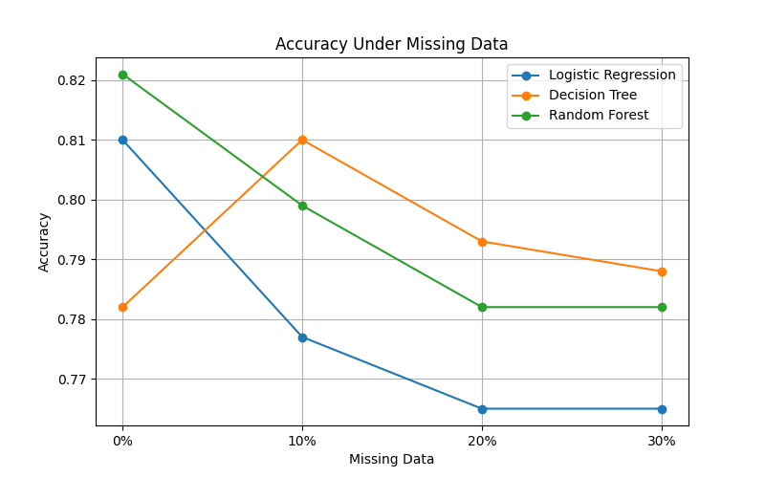
Author’s calculations.

F1-score
F1-score was used as an additional performance metric because it combines precision and recall. The F1-score results for Logistic Regression, Decision Tree, and Random Forest at different levels of missing data are presented below.

Table 2. F1-score of machine learning models under different levels of missing data
Missing Data | Logistic Regression | Decision Tree | Random Forest
0% | 0.764 | 0.742 | 0.778
10% | 0.73 | 0.773 | 0.757
20% | 0.724 | 0.745 | 0.738
30% | 0.724 | 0.725 | 0.727
Author’s calculations based on the experimental results.

The F1-score results show a similar overall decrease as the amount of missing data increased. Logistic Regression decreased from 0.764 at 0% missing data to 0.724 at 30%. Random Forest decreased from 0.778 to 0.727. Decision Tree initially increased from 0.742 to 0.773 at 10% missing data, but its F1-score subsequently decreased to 0.725 at 30%.

Figure 2. F1-score of machine learning models at different levels of missing data
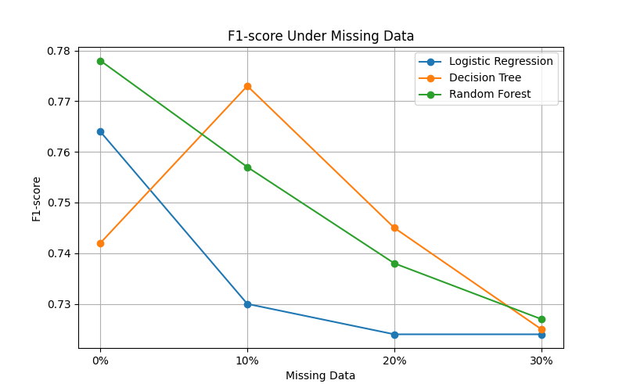
Author’s calculations.

2 Feature Selection Experiment
To evaluate the effect of feature selection on machine learning performance, experiments were conducted using different subsets of the available features. The performance of Logistic Regression, Decision Tree, and Random Forest was evaluated using Accuracy and F1-score. The results were compared to determine whether reducing the number of input features affects model performance.

The Accuracy results for the three feature configurations are presented in Table 3.
Feature Set | Logistic Regression | Decision Tree | Random Forest
Basic Features | 0.810 | 0.631 | 0.721
Extended Features | 0.810 | 0.749 | 0.810
All Features | 0.810 | 0.782 | 0.821
Author’s calculations based on the experimental results.

The results show that feature selection affected the models differently. Logistic Regression maintained an Accuracy of 0.810 across all three feature configurations. Decision Tree increased from 0.631 with Basic Features to 0.749 with Extended Features and 0.782 with All Features. Random Forest showed a similar improvement, increasing from 0.721 with Basic Features to 0.810 with Extended Features and 0.821 with All Features.

Figure 3. Accuracy of machine learning models under different feature configurations
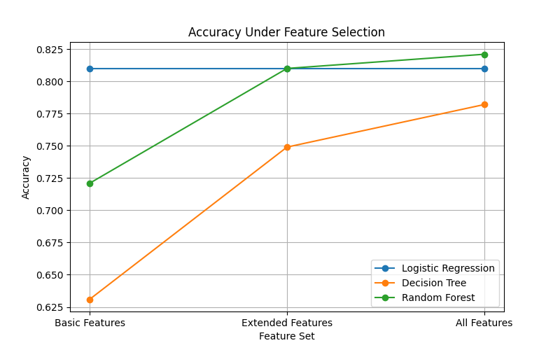
Author’s calculations.

The F1-score results for the three feature configurations are presented in Table 4.

Feature Set | Logistic Regression | Decision Tree | Random Forest
Basic Features | 0.761 | 0.522 | 0.643
Extended Features | 0.757 | 0.698 | 0.764
All Features | 0.764 | 0.742 | 0.778
Author’s calculations based on the experimental results.

The F1-score results show that feature selection had the greatest effect on the tree-based models. Decision Tree increased from 0.522 with Basic Features to 0.698 with Extended Features and 0.742 with All Features. Random Forest increased from 0.643 to 0.764 and then to 0.778. Logistic Regression remained relatively stable, with F1-score values of 0.761, 0.757, and 0.764 for Basic, Extended, and All Features, respectively

Figure 4. F1-score of machine learning models under different feature configurations
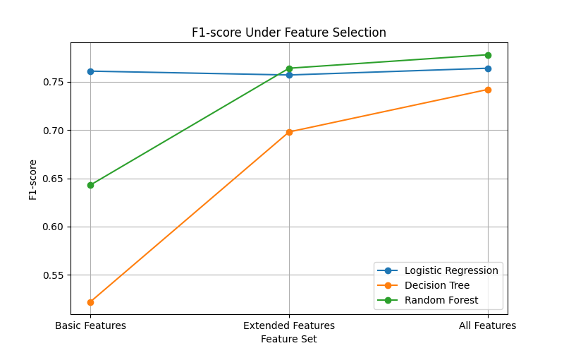
Author’s calculations.

3 Label Noise Experiment
To evaluate the effect of label noise on machine learning performance, controlled noise was introduced into the target labels at different levels. Four levels of label noise were tested: 0%, 10%, 20%, and 30%. Logistic Regression, Decision Tree, and Random Forest were evaluated using Accuracy and F1-score. The results were compared to determine how incorrect target labels affect model performance

Table 5. Accuracy of machine learning models under different levels of label noise

Label Noise | Logistic Regression | Decision Tree | Random Forest
0% | 0.810 | 0.782 | 0.821
10% | 0.469 | 0.531 | 0.480
20% | 0.196 | 0.223 | 0.184
30% | 0.196 | 0.352 | 0.263
Author’s calculations based on the experimental results.

The results show a substantial decrease in Accuracy as label noise increased. Logistic Regression decreased from 0.810 with 0% label noise to 0.469 at 10% and 0.196 at 20% and 30%. Random Forest decreased from 0.821 to 0.480 at 10%, 0.184 at 20%, and 0.263 at 30%. Decision Tree also decreased from 0.782 to 0.531 at 10% and 0.223 at 20%, although its Accuracy increased to 0.352 at 30%.
Figure 5. Accuracy of machine learning models at different levels of label noise
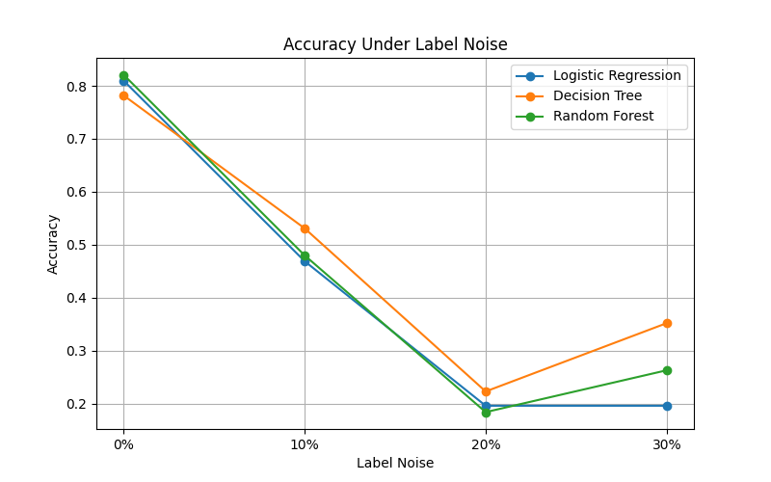
Author’s calculations.

Table 6. F1-score of machine learning models under different levels of label noise

Label Noise | Logistic Regression | Decision Tree | Random Forest
0% | 0.764 | 0.742 | 0.778
10% | 0.410 | 0.500 | 0.422
20% | 0.182 | 0.240 | 0.170
30% | 0.182 | 0.383 | 0.258
Author’s calculations based on the experimental results.
The F1-score results confirm the strong negative effect of label noise. Logistic Regression decreased from 0.764 at 0% noise to 0.410 at 10% and 0.182 at 20% and 30%. Random Forest decreased from 0.778 to 0.422 at 10%, 0.170 at 20%, and 0.258 at 30%. Decision Tree decreased from 0.742 to 0.500 at 10% and 0.240 at 20%, followed by an increase to 0.383 at 30%.

Figure 6. F1-score of machine learning models at different levels of label noise
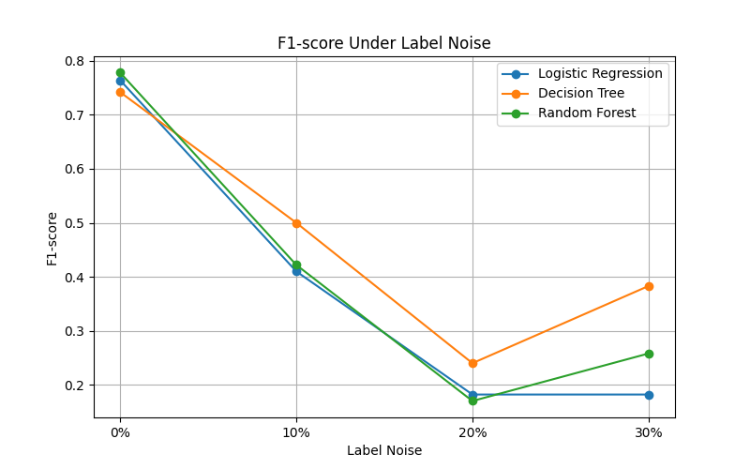
Author’s calculations

4 Comparison of Results
The results of the experiments were compared to determine how different data-quality conditions affected the performance of Logistic Regression, Decision Tree, and Random Forest. The comparison included missing data, feature selection, and label noise. Accuracy and F1-score were used as the main metrics because they provide complementary information about classification performance.

Table 7. Overall Accuracy of the Three Models Under Different Data-Quality Conditions.
Experiment | Logistic Regression | Decision Tree | Random Forest
Missing Data | 0.765 | 0.788 | 0.782
Label Noise | 0.196 | 0.352 | 0.263
Feature Selection | 0.810 | 0.782 | 0.821
Author’s calculations based on the experimental results.

Table 8. Overall F1-score Comparison
Experiment | Logistic Regression | Decision Tree | Random Forest
Missing Data | 0.724 | 0.725 | 0.727
Label Noise | 0.182 | 0.383 | 0.258
Feature Selection | 0.764 | 0.742 | 0.778
Author’s calculations based on the experimental results.

The numerical results show differences in model performance across the tested data quality conditions. To make these differences easier to compare, the results are presented graphically below.
Figure 7. Accuracy Comparison Across Data-Quality Conditions
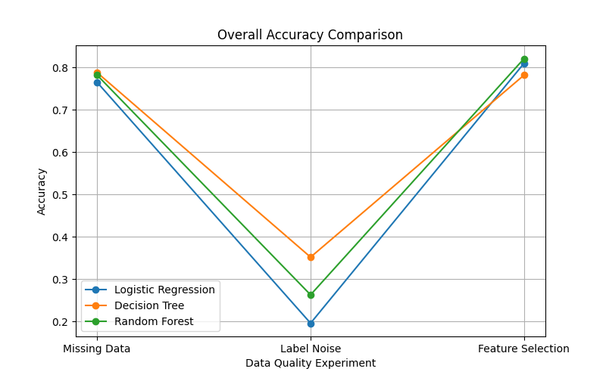
Author’s calculations

Figure 8. F1-score Comparison Across Data-Quality Conditions
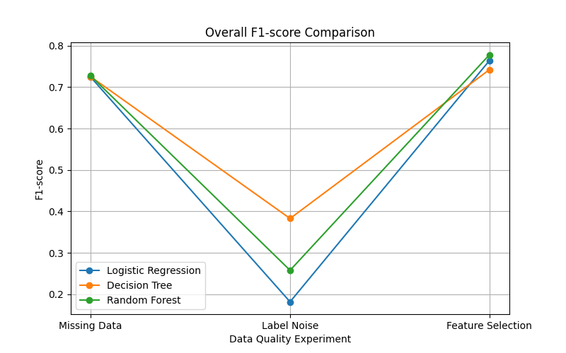
Author’s calculations
Analysis of Results
The comparison of the experimental results demonstrates that data quality had a substantial effect on the performance of all three machine learning models. However, the magnitude of this effect depended on the type of data-quality problem and on the model used. Among the three investigated factors, label noise produced the largest decrease in both Accuracy and F1-score, whereas missing data caused a comparatively smaller change in performance. Feature selection had a different effect, particularly for the tree-based models.
Label noise was the most influential data-quality factor in the experiment. At 30% label noise, Accuracy decreased to 0.196 for Logistic Regression, 0.352 for Decision Tree, and 0.263 for Random Forest, compared with 0.810, 0.782, and 0.821 respectively under the 0% noise condition. F1-score showed the same general pattern, decreasing to 0.182, 0.383, and 0.258. These results indicate that incorrect target labels can substantially reduce the ability of a model to learn the underlying relationship between the features and the target variable.
Missing data had a more moderate effect within the tested range. From 0% to 30% missing data, Random Forest Accuracy decreased from 0.821 to 0.782, while its F1-score decreased from 0.778 to 0.727. Similar moderate changes were observed for Logistic Regression and Decision Tree. This suggests that the preprocessing and structure of the dataset allowed the models to retain a considerable amount of predictive information despite the introduction of missing values.
Feature selection produced different effects across the models. Logistic Regression remained at an Accuracy of 0.810 across the tested feature configurations, while Decision Tree Accuracy increased from 0.631 with the basic feature set to 0.782 with all features. Random Forest showed a similar improvement, increasing from 0.721 to 0.821. The corresponding F1-score changes were also more pronounced for the tree-based models. These findings suggest that the amount of relevant information available to a model can be particularly important for non-linear models.
The comparison also demonstrates that algorithm choice influenced performance, but its effect was generally smaller than the effect of severe label noise in the current experimental setup. For example, under 30% label noise, the difference between the highest and lowest Accuracy among the three models was 0.156, whereas Logistic Regression alone experienced a decrease of 0.614 Accuracy points compared with its 0% noise condition. This indicates that changes in data quality can produce substantially larger performance differences than the choice between the three tested algorithms under certain conditions.
Overall, the results support the research hypothesis that data quality can have a greater influence on model performance than algorithm choice. However, this conclusion should be interpreted within the conditions of the present experiment. The study used one dataset, three classification algorithms, and a fixed experimental procedure. Therefore, the findings demonstrate a strong relationship within this experimental setting rather than establishing a universal rule for all machine learning applications.

Discussion
The findings of this study demonstrate that data quality is an important factor influencing the performance of machine learning classification models. Across the experiments, missing data, feature selection, and label noise affected Logistic Regression, Decision Tree, and Random Forest to different degrees. The strongest effect was observed for label noise, while missing data produced a more moderate change in performance. Feature selection had a model-dependent effect, particularly for the tree-based models.
The strong effect of label noise can be explained by the direct influence of incorrect target values on the learning process. When labels are incorrectly assigned, the model receives contradictory information about the relationship between the input features and the target. As the proportion of incorrect labels increases, the model has less reliable information from which to learn the underlying classification pattern. This explains why label noise produced a substantially larger performance decrease than the other investigated data-quality problems.
The results for missing data suggest that its effect depends on how much useful information remains available after preprocessing. In this study, missing values were handled during the preprocessing stage, which allowed the models to continue training despite incomplete observations. The relatively moderate performance decrease indicates that appropriate preprocessing can reduce the negative effect of missing values. However, this result should not be interpreted as evidence that missing data is generally harmless, since its impact may depend on the proportion, distribution, and mechanism of missingness.
Feature selection produced different effects across the three models. Logistic Regression was relatively stable across the tested feature configurations, whereas Decision Tree and Random Forest showed larger changes when features were added or removed. One possible explanation is that tree-based models can make use of interactions and non-linear relationships between features, meaning that removing informative variables may reduce their ability to separate observations effectively. The results therefore suggest that feature selection should be considered together with the characteristics of the chosen algorithm rather than treated as a universally beneficial preprocessing step.

The comparison between data quality and algorithm choice provides important evidence for the research question. Although the three algorithms produced different performance levels, severe deterioration in data quality could have a substantially greater effect than changing the algorithm itself. In particular, label noise caused a major reduction in performance across all three models. This indicates that selecting a more advanced algorithm cannot necessarily compensate for severely corrupted training data.
These findings support the research hypothesis that data quality can have a greater influence on machine learning model performance than algorithm choice. However, the results also show that this relationship is not absolute. The effect of data quality varied depending on the type of problem and the model. Therefore, data quality and algorithm selection should be considered as complementary factors when developing machine learning systems.
Several limitations should be considered when interpreting the findings. First, the experiments were conducted using the Titanic dataset, which limits the generalizability of the results to other datasets and application domains. Second, only three machine learning algorithms were evaluated. Third, the experiments used specific levels and configurations of missing data, feature selection, and label noise. Finally, the study focused on performance metrics obtained from the selected experimental procedure and did not investigate statistical uncertainty across a large number of independent train-test splits.
Future research could extend the study by using multiple datasets from different domains and evaluating a larger range of machine learning algorithms. Repeated train-test splits and cross-validation could also be used to assess the stability of the observed effects. Statistical analysis could further determine whether the differences between data-quality conditions are statistically significant. These extensions would provide stronger evidence about the general relationship between data quality and machine learning performance.

Conclusion
This study investigated the extent to which data quality affects the performance of machine learning classification models compared with the choice of algorithm. The experiments focused on three data-quality factors: missing data, feature selection, and label noise. Logistic Regression, Decision Tree, and Random Forest were evaluated using the Titanic dataset and the Accuracy and F1-score metrics.
The experimental results demonstrated that data quality had a substantial influence on model performance. Label noise produced the strongest negative effect, causing a significant decrease in both Accuracy and F1-score across all three models. Missing data had a more moderate effect, while feature selection affected the models differently, with Decision Tree and Random Forest showing greater sensitivity to the selected features than Logistic Regression.
The results indicate that data quality can have a greater influence on model performance than algorithm choice under certain conditions. Although the three algorithms showed differences in predictive performance, severe deterioration of data quality, particularly through label noise, resulted in substantially larger performance changes. Therefore, the research question is answered by demonstrating that the impact of data quality can exceed the impact of algorithm selection when the training data contains substantial quality problems.
The findings support the research hypothesis that data quality has a significant influence on machine learning model performance and can be more important than algorithm choice. However, the strength of this effect depends on the type of data-quality problem and the characteristics of the model. The results therefore emphasize that model selection should not replace careful data preparation and quality control.
Overall, this study demonstrates that reliable machine learning performance depends not only on the algorithm selected but also on the quality of the data used for training. Ensuring accurate labels, appropriate feature selection, and effective handling of missing values should therefore be considered essential parts of the machine learning development process. Further research using multiple datasets, additional algorithms, cross-validation, and statistical testing would help determine whether the observed patterns generalize to other machine learning applications.

References
Chandrashekar, G., & Sahin, F. (2014). A survey on feature selection methods. Computers & Electrical Engineering, 40(1), 16–28. https://doi.org/10.1016/j.compeleceng.2013.11.024
Emmanuel, T., Maupong, T., Mpoeleng, D., Semong, T., Mphago, B., & Tabona, O. (2021). A survey on missing data in machine learning. Journal of Big Data, 8, 140. https://doi.org/10.1186/s40537-021-00516-9
Frénay, B., & Verleysen, M. (2014). Classification in the presence of label noise: A survey. IEEE Transactions on Neural Networks and Learning Systems, 25(5), 845–869. https://doi.org/10.1109/TNNLS.2013.2292894
Jäger, S., Allhorn, A., & Bärnighausen, T. (2021). Missing value imputation affects the performance of machine learning: A review and analysis of the literature (2010–2021). Informatics in Medicine Unlocked, 27, 100799. https://doi.org/10.1016/j.imu.2021.100799
Li, J., Cheng, K., Wang, S., Morstatter, F., Trevino, R. P., Tang, J., & Liu, H. (2017). Feature selection: A data perspective. ACM Computing Surveys, 50(6), Article 94. https://doi.org/10.1145/3136625
Song, H., Kim, M., Park, D., Shin, Y., & Lee, J.-G. (2023). Learning from noisy labels with deep neural networks: A survey. IEEE Transactions on Neural Networks and Learning Systems, 34(11), 8135–8153. https://doi.org/10.1109/TNNLS.2022.3152527
Theng, D., & Bhoyar, K. K. (2024). Feature selection techniques for machine learning: A survey of more than two decades of research. Knowledge and Information Systems, 66(3), 1575–1637. https://doi.org/10.1007/s10115-023-02010-5

Appendices

Appendix A. Dataset and Preprocessing
The experiments were conducted using the Titanic dataset. The dataset was inspected and preprocessed before model training. Missing values were identified and handled during preprocessing, while categorical variables were converted into a numerical representation suitable for machine learning models. The same general preprocessing procedure was maintained across the experiments to ensure comparability of the results.

Table A1. Example of the Titanic Dataset

Passenger Id | Survived | Pclass | Name | Sex | Age | SibSp | Parch | Ticket | Fare | Cabin | Embarked
1 | 0 | 3 | Braund, Mr. Owen Harris | male | 22 | 1 | 0 | A/5 21171 | 7.25 | –- | S
2 | 1 | 1 | Cumings, Mrs. John Bradley (Florence Briggs Thayer) | female | 38 | 1 | 0 | PC 17599 | 71.28 | C85 | C
3 | 1 | 3 | Heikkinen, Miss. Laina | female | 26 | 0 | 0 | STON/O2. 3101282 | 7.925 | –- | S
4 | 1 | 1 | Futrelle, Mrs. Jacques Heath (Lily May Peel) | female | 35 | 1 | 0 | 113803 | 53.1 | C123 | S

Appendix B. Experimental Results
This appendix provides the complete numerical results obtained during the experiments. The tables supplement the results presented in Section 4 and provide the values used for the comparison of the three machine learning models.

Table B1. Missing Data — Accuracy
Missing Data | Logistic Regression | Decision Tree | Random Forest
0% | 0.81 | 0.782 | 0.821
10% | 0.777 | 0.81 | 0.799
20% | 0.765 | 0.793 | 0.782
30% | 0.765 | 0.788 | 0.782

Table B2. Missing Data — F1-score
Missing Data | Logistic Regression | Decision Tree | Random Forest
0% | 0.764 | 0.742 | 0.778
10% | 0.73 | 0.773 | 0.757
20% | 0.724 | 0.745 | 0.738
30% | 0.724 | 0.725 | 0.727

Table B3. Feature Selection — Accuracy
Feature Set | Logistic Regression | Decision Tree | Random Forest
Basic Features | 0.810 | 0.631 | 0.721
Extended Features | 0.810 | 0.749 | 0.810
All Features | 0.810 | 0.782 | 0.821

Table B4. Feature Selection — F1-score
Feature Set | Logistic Regression | Decision Tree | Random Forest
Basic Features | 0.761 | 0.522 | 0.643
Extended Features | 0.757 | 0.698 | 0.764
All Features | 0.764 | 0.742 | 0.778

Table B5. Label Noise — Accuracy
Label Noise | Logistic Regression | Decision Tree | Random Forest
0% | 0.810 | 0.782 | 0.821
10% | 0.469 | 0.531 | 0.480
20% | 0.196 | 0.223 | 0.184
30% | 0.196 | 0.352 | 0.263

Table B6. Label Noise — F1-score
Label Noise | Logistic Regression | Decision Tree | Random Forest
0% | 0.764 | 0.742 | 0.778
10% | 0.410 | 0.500 | 0.422
20% | 0.182 | 0.240 | 0.170
30% | 0.182 | 0.383 | 0.258

Table B7. Overall Accuracy Comparison
Experiment | Logistic Regression | Decision Tree | Random Forest
Missing Data | 0.765 | 0.788 | 0.782
Label Noise | 0.196 | 0.352 | 0.263
Feature Selection | 0.810 | 0.782 | 0.821

Table B8. Overall F1-score Comparison
Experiment | Logistic Regression | Decision Tree | Random Forest
Missing Data | 0.724 | 0.725 | 0.727
Label Noise | 0.182 | 0.383 | 0.258
Feature Selection | 0.764 | 0.742 | 0.778

Appendix C. Experimental Figures
This appendix presents additional figures generated during the experiments to provide a visual representation of model performance under different data-quality conditions.

Figure C1. Missing Data — Accuracy

Figure C2. Missing Data — F1-score

Figure C3. Feature Selection — Accuracy

Figure C4. Feature Selection — F1-score

Figure C5. Label Noise — Accuracy

Figure C6. Label Noise — F1-score

Figure C7. Overall Accuracy Comparison

Figure C8. Overall F1-score Comparison

Appendix D. Research Code and Reproducibility
The complete research code, experimental notebooks, dataset, result files, and generated figures are available in the project’s GitHub repository. The repository contains the materials required to inspect and reproduce the main stages of the experimental workflow, including data preprocessing, model training, data-quality modifications, evaluation, and comparison of results
GitHub Repository:
https://github.com/mksmedvedmain-boop/data-quality-vs-model-performance

